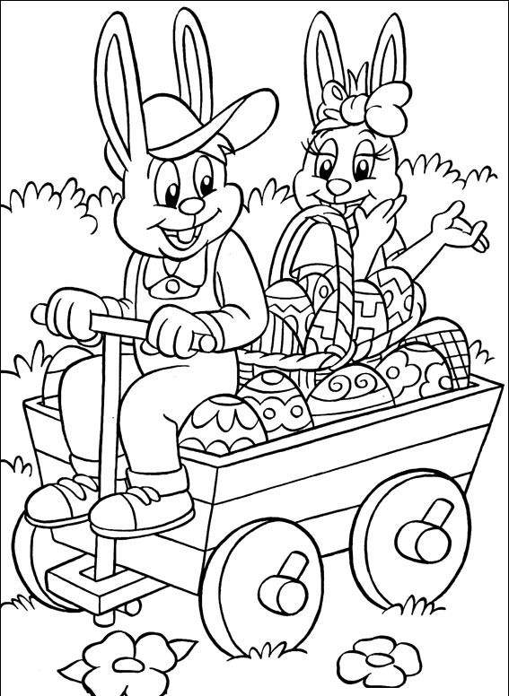
___ : 9 = 6
___ : 6 = 5
___ : 4 = 5
___ : 7 = 7
___ : 8 = 4
___ : 10 = 10
72 : ___ = 8
28 : ___ = 7
64 : ___ = 8
70 : ___ = 7
15 : ___ = 5
32 : ___ = 4
45 : 9 = ___
18 : 2 = ___
42 : 6 = ___
81 : 9 = ___
30 : 5 = ___
28 : 7 = ___
__ . 9 = 36
__ . 7 = 63
__ . 3 = 12
__ . 4 = 28
__ . 5 = 25
__ . 8 = 40

3 . __ = 27
8 . __ = 48
5 . __ = 45
4 . __ = 32

3 . __ = 27
8 . __ = 48
5 . __ = 45
4 . __ = 32

3 . __ = 27
8 . __ = 48
5 . __ = 45
4 . __ = 32

3 . __ = 27
8 . __ = 48
5 . __ = 45
4 . __ = 32

3 . __ = 27
8 . __ = 48
5 . __ = 45
4 . __ = 32

3 . __ = 27
8 . __ = 48
5 . __ = 45
4 . __ = 32

3 . __ = 27
8 . __ = 48
5 . __ = 45
4 . __ = 32

3 . __ = 27
8 . __ = 48
5 . __ = 45
4 . __ = 32

3 . __ = 27
8 . __ = 48
5 . __ = 45
4 . __ = 32

3 . __ = 27
8 . __ = 48
5 . __ = 45
4 . __ = 32

3 . __ = 27
8 . __ = 48
5 . __ = 45
4 . __ = 32

3 . __ = 27
8 . __ = 48
5 . __ = 45
4 . __ = 32
Vypočítaj:
3 . __ = 27
8 . __ = 48
5 . __ = 45
4 . __ = 32

9 . 6 = __
7 . 5 = __
2 . 9 = __
8 . 7 = __
7 . __ = 42
3 . __ = 27
8 . __ = 48
5 . __ = 45
4 . __ = 32

